

FOR LEASE

FLEX SPACE
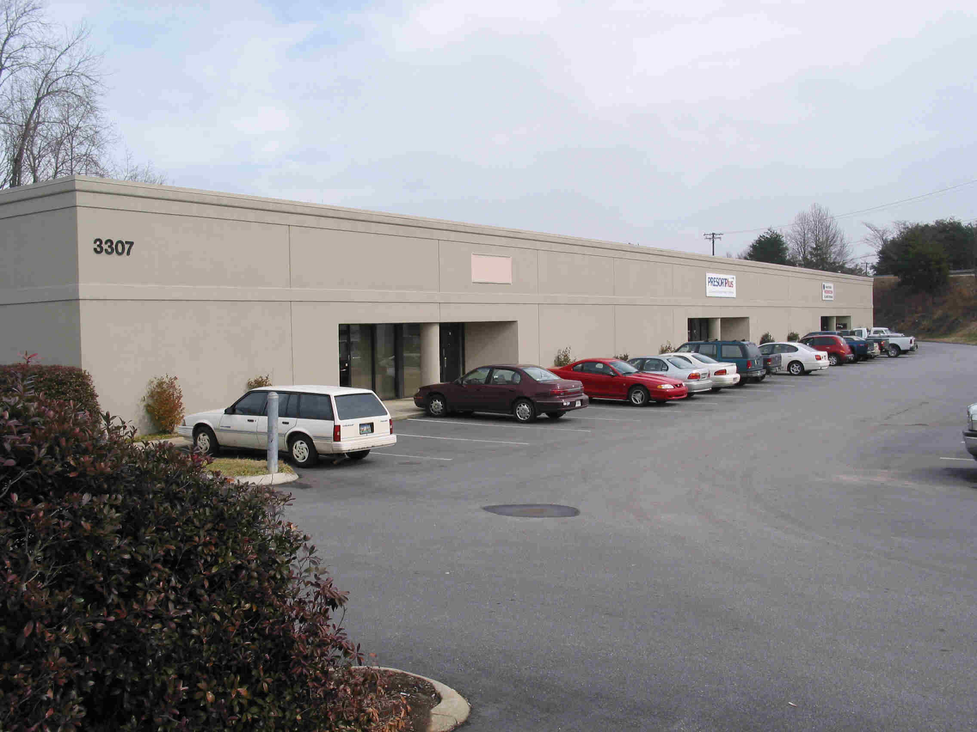

RUTHERFORD PARK IN TAYLORS, SC
3305 and 3307 Rutherford Road

- 1,200 square feet up to 3,200 sf with dock
- Suite 3307-B offers 3,200 sf in ‘Shell Condition’ and warehouse with dock access
- Suite 3305-B/C: 2,400 sf with 1,310 sf office - 1,090 sf w’house (dock and grade access)
- Rental rates are $10.00 office and $4.50 warehouse (including ‘base year’ taxes, ins.)
- CAM fees for water/sewer, landscaping, trash dumpster, and management $1.00 psf

For more information, call: Chris Covington, CCIM at 864-483-8811
(chris@covingtoncom.com)

PRESENTLY IN SHELL CONDITION


